**Cloud to Ground**

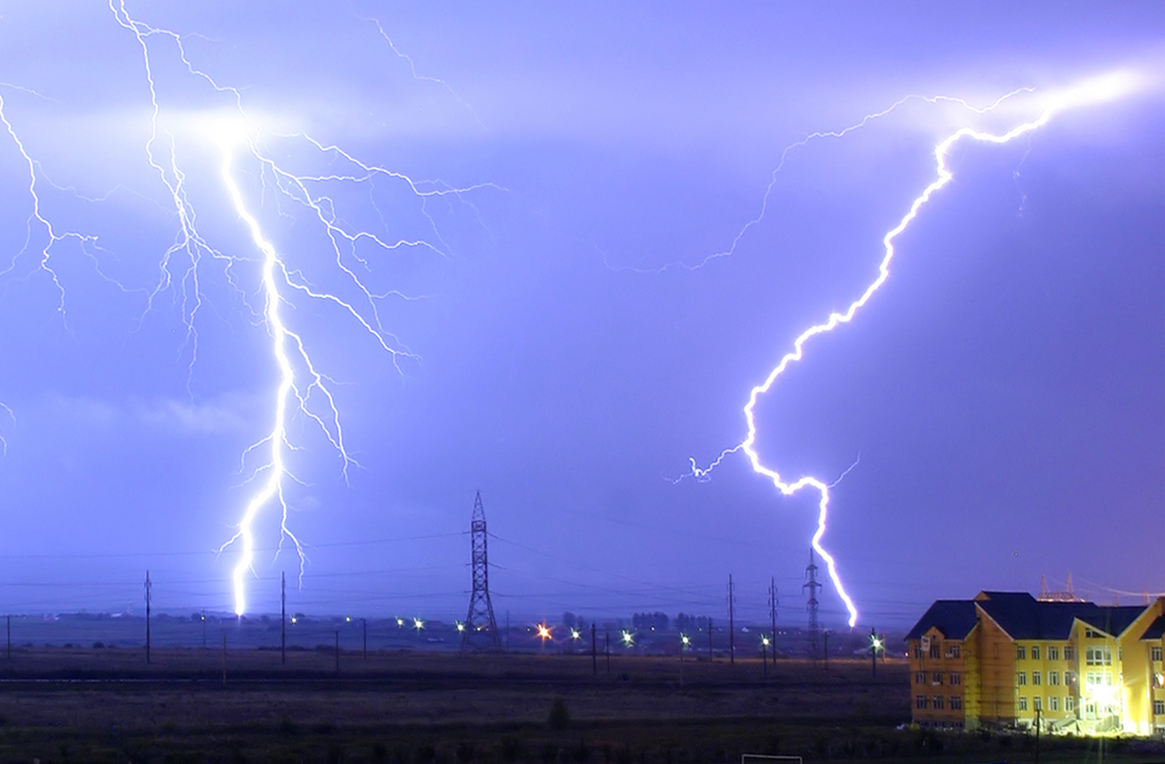

[This Photo](http://en.wikipedia.org/wiki/File:Lightning_over_Oradea_Romania_zoom.jpg) by Unknown Author is licensed under [CC BY-SA](https://creativecommons.org/licenses/by-sa/3.0/)

**Lightning Strikes**

**Continental United States**

**1987 to 2018**